|  |
| --- |
| SYI Games |
| 3D FPS Box Killer |
|  |
| Version #0.3.8  All work Copyright © 2015 by SYI Games.  All rights reserved. |
| **[Sangbeom Yi; 300857600]** |
|  |

**Logo.png**

|  |
| --- |
| October 5, 2015 |

**Table of Contents**

[Your Table of Contents should go here. Make sure that your document’s sections are hyperlinked to their corresponding pages.]

**# GitHub (it’s more newest than eCentennial Dropbox)**https://github.com/SeanSBYi/3DFPS_Box_Killer  
~~https://github.com/SeanSBYi/3DFPS_BoxKiller_300857600~~

**Version History**

--------------------------------------------------------------------------------

All Source code has each version History

|  |
| --- |
|  |
| C:\Users\SB.Y\AppData\Local\Microsoft\Windows\INetCache\Content.Word\Cap 2015-11-20 09-43-43-290.png |

--------------------------------------------------------------------------------

Version 0.1.0  
Create default Camera, Player (in the Class)

Version 0.1.1  
 Player can shot and hit (in the Class)

Version 0.1.2  
Make an Enemy (in the Class)

Version 0.1.3  
Player Score & Life board

Version 0.2.1  
Moving the Enemy

Version 0.3.8  
Stage 1 Basic Stage

-----------------------------------------------------------------------------------------

1. **Game Overview**

*Avoid the enemy and kill them. Player have to get the high score!*

1. **Game Play Mechanics**

*Shot and Kill the enemy.*

1. **Camera**

*3D First Person Shooting*

1. **Controls**

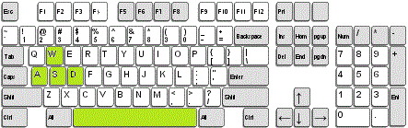

* *W, A, S, D Key : Move the Player*
* *Space :Jump*

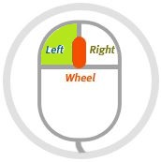

* *Left Mouse : Shot*

1. **Menu and Screen Descriptions**

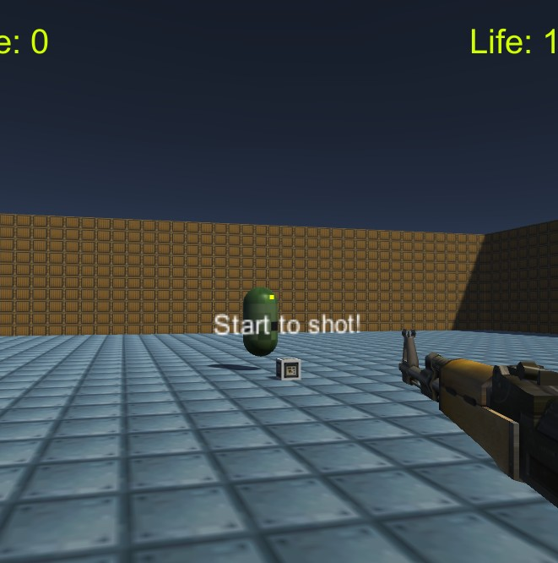

*[Menu Game Screen]*

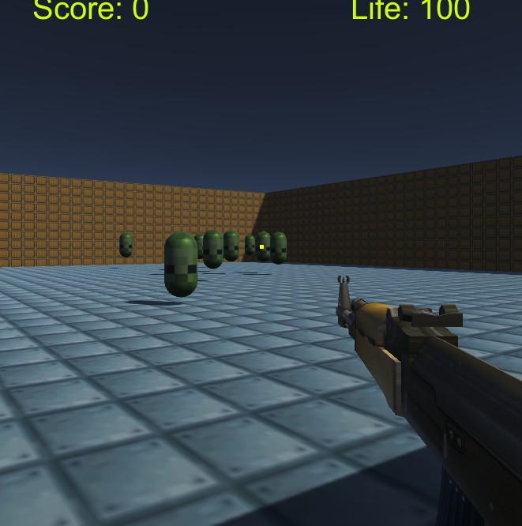

*[Main Game Screen]*

1. **Game Progression, Levels**

*Level 1 is only box map.*

*( After level 2will be more complicate map including some traps )*

1. **Enemies, Non-player Characters**

*All enemies follow the player and hit the player.  
Boss can shot the bullet (Version 0.8.1 Expected)*

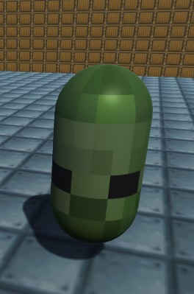

*[Normal Enemy]*

1. **Weapons**

*1. Normal shot*

*2. Homing shot: Rocket? (Version 0.7.1 Expected)*

1. **Items (Version 0.5.1 Expected)**
2. *Shield*
3. *HP Recover*
4. *Double Score*
5. **Scoring**

*Enemy : 100 point*

1. **Future Features**

*Various Player’s Weapon*

*More Player’s Weapon (Rocket, etc)*

*Various Type of Enemy*

*New Design and Animation*

*Items*

*New Stage  
 Level 1 : Simple box map  
 Level 2 : Small Maze  
 Level3 : Huge Field  
 Level4 : Tower  
 Level5 : Boss*

*New Platform  
 Unity Web Player, Mobile*